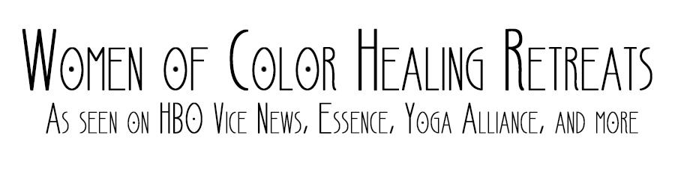

Yoga/ Meditation Teacher Application

WOCHR/BWYR provides a space for black women who are passionate about their yoga practice to learn, heal, and grow their community. Motivated by passion, this online virtual community strives to give all participants the very best opportunities. All yoga teachers should understand the importance of self care and the specific spiritual, emotional, and psychological needs of black women.

To be part of the WOCHR virtual community, please be a certified yoga teacher. Though we know that certification isn’t something that everyone can obtain for various reasons, we want to ensure that all of our participants receive an array of informative classes of quality that also ensure their safety. We ask several questions on our applications but it is not required to be an expert or to know everything. All WOCHR/BWYR’s Yoga instructors are required to have one or more of the following certifications:
RYT 200
RYT 500
E-RYT 200
E-RYT 500
If you connect with our goal of bringing black women deeper into their spiritual selves, and are a certified yoga teacher, please fill-out the form below as soon as possible, and we look forward to connecting with you!

APPLICATION

- Name
- Facebook
- Instagram
- Tell us about yourself, age, hobbies, where are you from etc
- What state do you reside in?
- Why is it important to you for black women to have spaces to learn, heal and grow together?
- What are some of your favorite books?
- What Yoga certification do you hold? What school did you complete it ? Please tell us about your experience.
- Are you familiar with the chakras? Tell us in details your experience
- Do you know Sanskrit?
- What specific type of yoga do you teach?
- How long have you been teaching?
- How long have you been practicing yoga?
- How many days/ hours per week do you practice yoga?
- What are the name(s) of some of your teacher (s) and guide(s)? Please provide links to their social media pages and websites if they have one.
- Do you also teach guided meditation?
- Tell us about your spiritual connection with yoga?
- Are you capable of holding space/workshop with other instructors to teach women a bit more about yoga?
- What are some of the basic philosophies and theories of your yoga practice?
- Do you have any relatives or friends on the WOCHR team?

